SE 4485: Software Engineering Projects

Fall 2026

Detailed Design Documentation

Group Number | 9
Project Title | Skills Catalog & Inventory (Team A)
Sponsoring Company | Sabre Corporation
Sponsor(s) | Jeff Buchmiller
Students | 1.Tobenna Nwosu  2. Jason Lehman  3. Alice Askerup  4. Russel Costales  5. Kim Chau  6. Jasmine Shrestha

Skills Catalog & Inventory

- ABSTRACT
This is the Detailed Design Documentation for the Skills Catalog & Inventory project sponsored by Sabre Corporation. This project is one of the ten projects for this course SE 4485.001 at the University of Texas at Dallas. This document complies with the Software Engineering Standards set by the IEEE Standard for Software Project Management Plans (IEEE Std 1058-1998). The document sets the architectural design and structure for the project.

B. TABLE OF CONTENTS

Abstract……………………………………………………………………………………….…....3
- Table of Contents…………………………………………………………………………….…….4
- List of Figures……………………………………………………………………………………...5
- List of Tables………………………………………………………………………………….……5
- Introduction……………………………………………………………………………….….…….
1.1. Introduction to the document…………………………………………………………….……
1.2. Purpose and Scope of the document…………………………………………………….….…
1.3. Description of the structure of the document………………………………………….………
- GUI (Graphical User Interface) Design
- Static Model
- Dynamic Model
- Rationale for your Detailed Design Model
- Traceability from Requirements to Detailed Design Model
- Evidence the Design Model has been placed under configuration
- Engineering Standards and Multiple Constraints
- Additional References

LIST OF FIGURES

LIST OF TABLES

1. INTRODUCTION

1.1 Introduction to the entire document
The Detailed Design Documentation describes the design details of the Skills Catalog & Inventory (Team A) project. This document provides an overview of the system’s architecture, structure, and the interactions between different components. This document serves as a guide for the team to develop the system by explaining how the system’s requirements will be translated into a detailed design that supports implementation.

1.2 Purpose and scope of the document
The purpose of this Detailed Design Document is to describe the system’s internal structure, user interface design, and interactions between components for the Skills Catalog and Inventory application. It translates the functional and non-functional requirements into a detailed technical design that will guide the implementation, testing, and integration of the system's components. This document will include class diagrams to visually represent the system's classes, attributes, methods, and relationships. The document will also include GUI diagrams to outline the layouts, navigation, and interactive elements of the user interface for each stakeholder role. Sequence diagrams will also be included to demonstrate the order of interaction between users, system components, and the database during key operations. This document and diagrams will serve as a technical reference for the development team to ensure that the system’s architecture and user experience align with the outlined functional and non-functional requirements

1.3 Description of the structure of the document
This Detailed Design Document bridges the gap between the requirements and how it is implemented. The document is organized into the following sections:
- Introduction: Introduces the document while explaining its purpose and scope.
- GUI (Graphical User Interface) Design: Presents the GUI design of the Skills Catalog and Inventory.
- Static Model: Presents the static model of the system using UML class diagrams to show the classes, their attributes and operations, and the relationship among them.
- Dynamic Model: Presents the dynamic model of the system using UML sequence diagrams to show how objects interact over time.
- Rationale for the detailed design model: Gives the rationale for detailed design model while explaining the design decisions, alternatives considered, and the patterns and principles applied.
- Traceability from requirements to detailed design model: Maps requirements in Requirements Documentation to design elements that satisfy it.
- Configuration management: Links to relevant repository management tools.
- Engineering Standards and Multiple Constraints: Lists the industry standards guiding the project.
- Glossary and Additional References: Defines key terms and provides supporting references.

2. GUI (Graphical User Interface) Design
- screen designs (coded or using drawing tool)

https://www.figma.com/site/4MErdkV6ukx8CgcgEeqLpP/GUI-Design?node-id=0-1&p=f&t=f6I4wJtNxJAzIoNx-0

3. Static Model: CLASS DIAGRAM (Captured in draw.io)
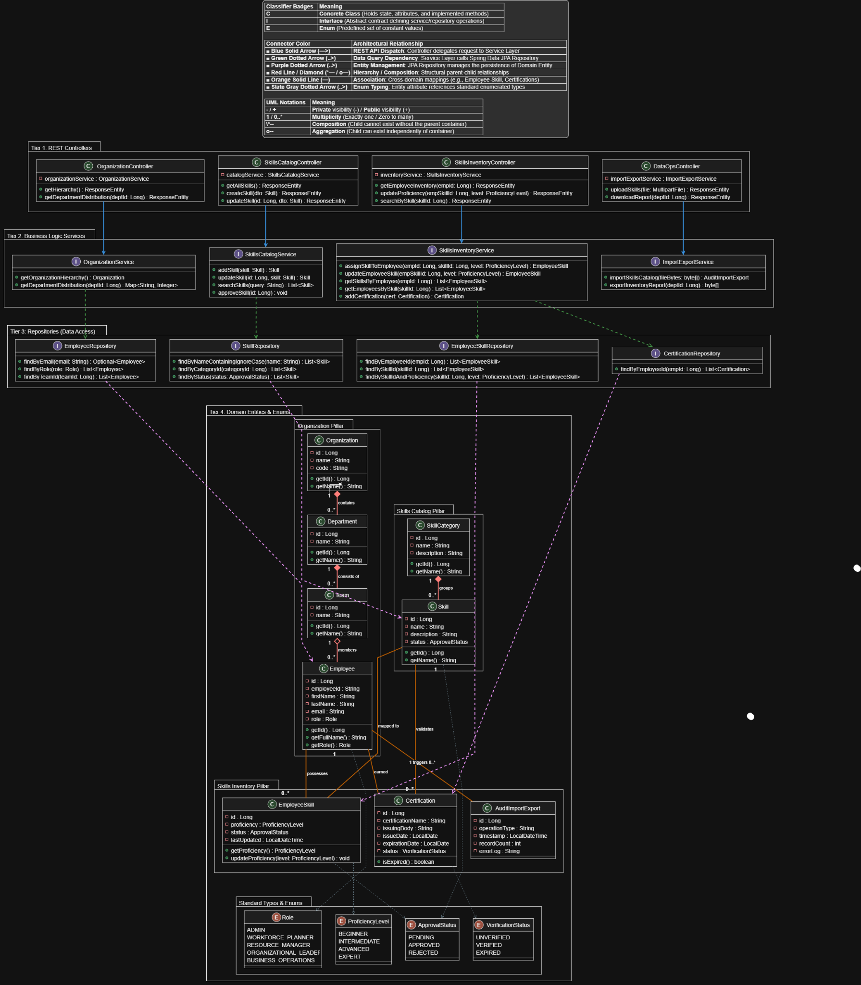

3.2 Tier Decomposition
- Tier 1: REST Controllers (API Layer)
  - Provides HTTP/REST endpoints connecting the React/TypeScript frontend to the backend application server.
  - Dispatches transport DTOs (Data Transfer Objects) and handle response entity encapsulation for all user interactions.
- Tier 2: Business Logic Services (Service Layer)
  - Implements enterprise business logic, validation rules, transactional integrity, and data transformation routines.
  - Serves as an abstraction layer between presentation endpoints and database persistence.
- Tier 3: Repositories (Data Access Layer)
  - Uses Spring Data JPA interfaces extending JpaRepository to abstract SQL operations against the PostgreSQL database.
  - Defines standard and custom query methods for personnel, skill catalog definitions, and inventory mappings.
- Tier 4: Domain Entities & Enums (Persistence Layer)
  - Comprises persistent JPA entity classes mapped to relational tables and enumerated types enforcing standardized domain values.
  - Organized into three domain pillars: Organization, Skills Catalog (Master Data), and Skills Inventory (Operational Data).

3.3 Detailed Class Specifications by Tier

Tier 1: REST Controllers
- OrganizationController [Class]
  - Attributes:
    - - organizationService : OrganizationService
  - Operations:
    - + getHierarchy() : ResponseEntity
    - + getDepartmentDistribution(deptId: Long) : ResponseEntity
- SkillsCatalogController [Class]
  - Attributes:
    - - catalogService : SkillsCatalogService
  - Operations:
    - + getAllSkills() : ResponseEntity
    - + createSkill(dto: Skill) : ResponseEntity
    - + updateSkill(id: Long, dto: Skill) : ResponseEntity
- SkillsInventoryController [Class]
  - Attributes:
    - - inventoryService : SkillsInventoryService
  - Operations:
    - + getEmployeeInventory(empId: Long) : ResponseEntity
    - + updateProficiency(empSkillId: Long, level: ProficiencyLevel) : ResponseEntity
    - + searchBySkill(skillId: Long) : ResponseEntity
- DataOpsController [Class]
  - Attributes:
    - - importExportService : ImportExportService
  - Operations:
    - + uploadSkills(file: MultipartFile) : ResponseEntity
    - + downloadReport(deptId: Long) : ResponseEntity

Tier 2: Business Logic Services
- OrganizationService [Interface]
  - Operations:
    - + getOrganizationHierarchy() : Organization
    - + getDepartmentDistribution(deptId: Long) : Map<String, Integer>
- SkillsCatalogService [Interface]
  - Operations:
    - + addSkill(skill: Skill) : Skill
    - + updateSkill(id: Long, skill: Skill) : Skill
    - + searchSkills(query: String) : List<Skill>
    - + approveSkill(id: Long) : void
- SkillsInventoryService [Interface]
  - Operations:
    - + assignSkillToEmployee(empId: Long, skillId: Long, level: ProficiencyLevel) : EmployeeSkill
    - + updateEmployeeSkill(empSkillId: Long, level: ProficiencyLevel) : EmployeeSkill
    - + getSkillsByEmployee(empId: Long) : List<EmployeeSkill>
    - + getEmployeesBySkill(skillId: Long) : List<EmployeeSkill>
    - + addCertification(cert: Certification) : Certification
- ImportExportService [Interface]
  - Operations:
    - + importSkillsCatalog(fileBytes: byte[]) : AuditImportExport
    - + exportInventoryReport(deptId: Long) : byte[]

Tier 3: Repositories (Data Access)
- EmployeeRepository [Interface]
  - Operations:
    - + findByEmail(email: String) : Optional<Employee>
    - + findByRole(role: Role) : List<Employee>
    - + findByTeamId(teamId: Long) : List<Employee>
- SkillRepository [Interface]
  - Operations:
    - + findByNameContainingIgnoreCase(name: String) : List<Skill>
    - + findByCategoryId(categoryId: Long) : List<Skill>
    - + findByStatus(status: ApprovalStatus) : List<Skill>
- EmployeeSkillRepository [Interface]
  - Operations:
    - + findByEmployeeId(empId: Long) : List<EmployeeSkill>
    - + findBySkillId(skillId: Long) : List<EmployeeSkill>
    - + findBySkillIdAndProficiency(skillId: Long, level: ProficiencyLevel) : List<EmployeeSkill>
- CertificationRepository [Interface]
  - Operations:
    - + findByEmployeeId(empId: Long) : List<Certification>

Tier 4: Domain Entities & Enums

Organization Pillar
- Organization [Class]
  - - id : Long
  - - name : String
  - - code : String
  - + getId() : Long
  - + getName() : String
- Department [Class]
  - - id : Long
  - - name : String
  - + getId() : Long
  - + getName() : String
- Team [Class]
  - - id : Long
  - - name : String
  - + getId() : Long
  - + getName() : String
- Employee [Class]
  - - id : Long
  - - employeeId : String
  - - firstName : String
  - - lastName : String
  - - email : String
  - - role : Role
  - + getId() : Long
  - + getFullName() : String
  - + getRole() : Role

Skills Catalog Pillar (Master Data)
- SkillCategory [Class]
  - - id : Long
  - - name : String
  - - description : String
  - + getId() : Long
  - + getName() : String
- Skill [Class]
  - - id : Long
  - - name : String
  - - description : String
  - - status : ApprovalStatus
  - + getId() : Long
  - + getName() : String

Skills Inventory Pillar (Operational Data)
- EmployeeSkill [Class]
  - - id : Long
  - - proficiency : ProficiencyLevel
  - - status : ApprovalStatus
  - - lastUpdated : LocalDateTime
  - + getProficiency() : ProficiencyLevel
  - + updateProficiency(level: ProficiencyLevel) : void
- Certification [Class]
  - - id : Long
  - - certificationName : String
  - - issuingBody : String
  - - issueDate : LocalDate
  - - expirationDate : LocalDate
  - - status : VerificationStatus
  - + isExpired() : boolean
- AuditImportExport [Class]
  - - id : Long
  - - operationType : String
  - - timestamp : LocalDateTime
  - - recordCount : int
  - - errorLog : String

Standard Types & Enums
- Role [Enum]: ADMIN, WORKFORCE_PLANNER, RESOURCE_MANAGER, ORGANIZATIONAL_LEADER, BUSINESS_OPERATIONS
- ProficiencyLevel [Enum]: BEGINNER, INTERMEDIATE, ADVANCED, EXPERT
- ApprovalStatus [Enum]: PENDING, APPROVED, REJECTED
- VerificationStatus [Enum]: UNVERIFIED, VERIFIED, EXPIRED

4. Dynamic Model
SEQUENCE DIAGRAMS
- captured in Rose (other tools are also allowed)

5. RATIONALE FOR YOUR DETAILED DESIGN MODEL

6. TRACEABILITY FROM REQUIREMENTS TO DETAILED DESIGN MODEL
- provide a mapping between requirements and detailed design model
- clearly describe how each requirement in the Requirements Documentation is captured in the design

General / Business Operations Functional Requirements | Traces to Detailed Design Model
Import Skills Catalog | DataOpsController.uploadSkills(file) calls ImportExportService.importSkillsCatalog(fileBytes) to import the Skills Catalog data.
Load additional skills | SkillsCatalogController.createSkill(dto) calls SkillsCatalogService.addSkills(skill) to load additional skills.
Validate Imported Data | Missing validate method
View Import Errors/Results | Missing method showing errors and results
Export Data | DataOpsController.downloadReport(deptld) calls ImportExportService.exportInventoryReport(deptld) to export the data.
Backup | Missing method for backup
Restoration | Missing restoration method
Approve or deny additional skills | Missing denial method
Web-based system | REST Controllers, including OrganizationController, SkillsCatalogController, SkillsInventoryController, and DataOpsController, provide endpoints for communication with the web-based front-end.
Cancel | Missing cancellation method

Workforce Planner Functional Requirements | Traces to Detailed Design Model
Views Skills Catalog | SkillsCatalogController.getAllSkills() retrieves Skills Catalog from SkillsCatalogService (missing getAllSkills() method)
Add Skills | SkillsCatalogController.createSkill(dto) receives new skill information, and SkillsCatalogService.addSkills(skill) helps add new skills to the catalog
Update Skills | SkillsCatalogController.updateSkill(id, dto) receives updated skill information, and SkillsCatalogService.updateSkills(id, skill) updates the existing skill
Search Skills | SkillsCatalogService.searchSkills(query) uses SkillRepository.findByNameContainingIgnoreCase(name) to retrieve matching skills.
View Skills Details | Missing method to retrieve an individual skill
Maintain Skill Type | Missing methods for adding, updating, or deleting skill categories
Maintaining Skill Proficiency Levels | SkillsInventoryController.updateProficiency(empSkillId, level) calls SkillsInventoryService.updateEmployeeSkill(empSkillId, level) to update an employee’s assigned skill proficiency level
Graphical UI | No UI class defined in the model
AI assistance | No AI assistance classes or methods are defined in the model

Resource Manager Functional Requirements | Traces to Detailed Design Model
Creating/Maintaining Skills Inventory | SkillsCatalogController.createSkill() calls SkillsCatalogController to create a new skill and SkillsCatalogController.updateSkill() calls SkillsCatalogController to update that skill., SkillsCatalogService.addSkill(), SkillsCatalogService.updateSkill(), and SkillsCatalogService.approveSkill() all call SkillsCatalogService to help work on the catalog.(missing creating a skills inventory)
Search for a specific resource or organization to view their skills | SkillsInventoryService.getSkillsByEmployee(empId) calls SkillsInventoryService to see skills (missing link to see resources or organization to view skills)
Search for a specific skill and see all associated resources | SkillsInventoryController.searchBySkill(skillId) calls SkillsInventoryController to do search. SkillsInventoryService.searchBySkill(skillID) calls SkillsInventoryService to call the SkillsInventoryController to do the search. EmployeeSkillRepository.findBySkillId(skillId) calls all of the employees linked to the skills (Only shows employees, not any other resources)
View UI | No view UI or anything associated to it are defined in model
Create, view, and maintain association between skill and resource | SkillsInventoryController.assignSkillToEmployee(), SkillsInventoryController.updateProficiency(), and SkillsInventoryController.getEmployeeSkills() calls SkillsInventoryController calls for SkillsInventoryControl that creates the connection between the employee and the skill assigned to them.
View specific Skill UI | SkillsCatalogController.getAllSkills(), SkillsCatalogController.createSkill(), and SkillsCatalogController.updateSkill() calls SkillCatalogController to update those skills. SkillsCatalogService.searchSkills(query), SkillsCatalogService.addSkill(), and SkillsCatalogService.updateSkills() to SkillsCatalogServer to call SkillsCatalogController to update or show those skills. (Missing specific view Skill UI)
Skill Validation | SkillsCatalogService.approveSkill(id: Long) approve skill by calling SkillsCatalogService
Certification Tracking | SkillsInventoryService.addCertification(empId, cert) calls SkillsInventoryService to add Certification

Organizational Leader Functional Requirements | Traces to Detailed Design Model
View summary | OrganizationController.getDepartmentDistribution(deptId) method calls OrganizationService.
Filter Skills | SkillsCatalogController.getAllSkills() and SkillsCatalogService.searchSkills(query) call SkillsCatalogController to search and show all skills. SkillsRepository.findByNameContainingIngoreCase(name) call SkillsRepository to find all skills. (missing explicit filtering options and approval status)
View distribution | Missing distribution of employee data
Graphical views | Missing graphical of employee data
Skill capacity | Missing data about skills capacity, resources availability, and other capacity analytics.
Skill Trend & Historical Analytics | Missing proficiency records, trend calculations, analytics services
Organization Hierarchy | OrganizationService.getOrganizationHierarchy() and OrganizationSerivice.getDepartmentDistribution(deptId) calls OrganizationService to provide hierarchy and distribution while OrganizationController.getDepartmentDistribution(deptId) calls for the OrganizationController and OrganizationRepository.findByTeamId(teamId) support retrieving organization structure and department distribution.

7. Configuration Management
- Github Repository: https://github.com/kimchau123/SE-4385-Group-9

Name | Version Before | Version After | Difference between 2 consecutive versions | Review | Comments
Tobenna | 0.00 | 0.01 | Documented Created | Shipped | Start of Our Detailed Design documentation
Tobenna | 0.01 | 0.02 | Template Added to Document | Shipped
Jasmine | 0.02 | 0.03 | Abstract | Shipped
Kim | 0.03 | 0.04 | Introduction to the entire document | Shipped
Jason | 0.04 | 0.05 | Purpose and Scope | Shipped
Jasmine | 0.05 | 0.06 | Description of the structure of the document | Shipped
Kim | 0.06 | 0.07 | Traceability from requirements to detailed design mode for Generical/Business Operations and Workforce Planner. | Shipped
Tobenna / Jason | 0.07 | 0.08 | Static Model | Shipped
Tobenna | 0.08 | 0.09 | Dynamic Model | In progress
Russel / Alice / Tobenna / Kim | 0.09 | 0.10 | GUI Design | In progress
Alice | 0.10 | 0.11 | Traceability from requirements to detailed design mode for Resource Manager and Organization Leader. | Shipped

8. Engineering Standards and Multiple Constraints

- IEEE Std 1016-1998-(Revision-2009): Software Design [pdf]

Students should work with their project sponsor(s) to identify all the standards and constraints that should be applied for preparing this document. Additional materials that are not listed above can be included.

9. Glossary

- Additional References

- Larman, C., 2012. Applying UML and Patterns: An Introduction to Object Oriented Analysis and Design and Iterative Development. Pearson Education
- Hyman, B., 1998. Fundamentals of Engineering Design. New Jersey: Prentice Hall
- Simon, H.A., 2014. A Student's Introduction to Engineering Design: Pergamon Unified Engineering Series (Vol. 21). Elsevier

Each group may include other related references that are not listed above.

